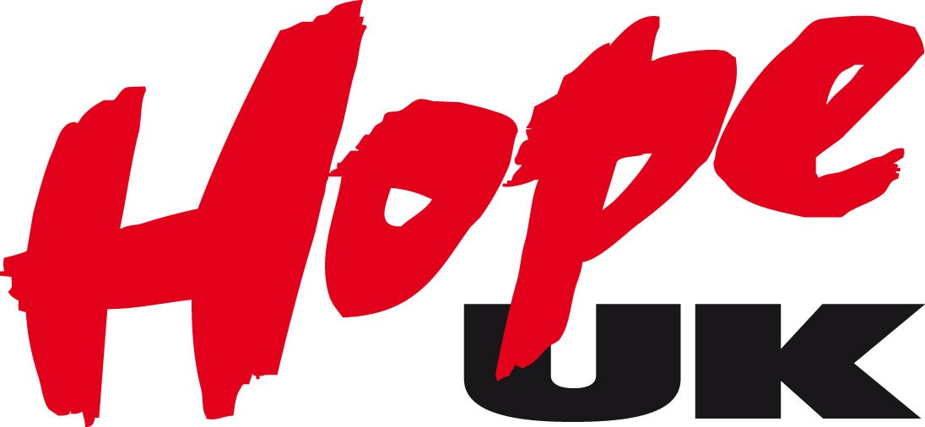

Hope UK

Annual Review 2017
  - Equipping young people to make drug-free choices

Contents
Introduction from the CEO 0
Changing Hope UK for New Developments: 1
Generation Hope – Our Youth Branch 2
Our Drug Prevention Work 4
What people said about us: 5
Statement of Financial Position 6
Balance Sheet 7

Introduction from the CEO

Welcome to our 2017 Annual Review.
2017 was a year of change for us, as we worked to get ourselves in place to grow both our educational work and our youth branch – Generation Hope. You may know that Hope UK started life as the Band of Hope – in 1847 – and youth clubs were run for young people throughout the UK. As we grew, the organisation developed preventative educational work, until somewhere in the late 20th Century the educational work took over and the direct youth work stopped. As we have developed courses and other work for young people we have been repeatedly asked to restart our direct youth work, so our youth branch was (re)born!
This does not mean we are stopping our educational work. Although we did not make this the main focus in 2017, our drug prevention and education sessions and our detached stands continue to be a central part of what we do, mostly through our voluntary educators working in their local communities throughout the UK. These highly committed people are also helping us develop our youth branch – helping train and support young people as they learn how to deliver peer education, train adults and generally get involved with our work.
Although statistics suggest a long-term trend downwards in drug use in the UK, there has been an increase in people seeking treatment for drugs including opioid users, and there has also been a rise in drug-related deaths. Our work continues to be of vital importance, and we will particularly be looking to recruit more volunteers throughout the UK in 2018. I am so grateful to the people who give their time freely to help us in this important work.

Changing Hope UK for New Developments:

Releasing a central London asset to increase work in the UK
In 2017, we sold our building in Copperfield Street. As we had an empty office in Kettering, it seemed appropriate to release capital AND save money by moving the Head Office outside of London.
Head Office staff now work in two locations – our main office in Kettering, and a smaller office in Stepney, East London.
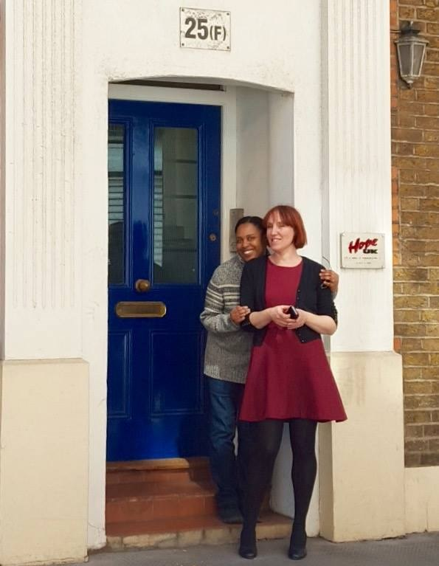

Restructuring the team
At the end of 2016, two members of staff left for new work elsewhere. Meanwhile, we decided to restructure our staff team to reflect the new developments here at Hope UK. This meant new job roles, so we recruited two new staff members - based in our office at Kettering.
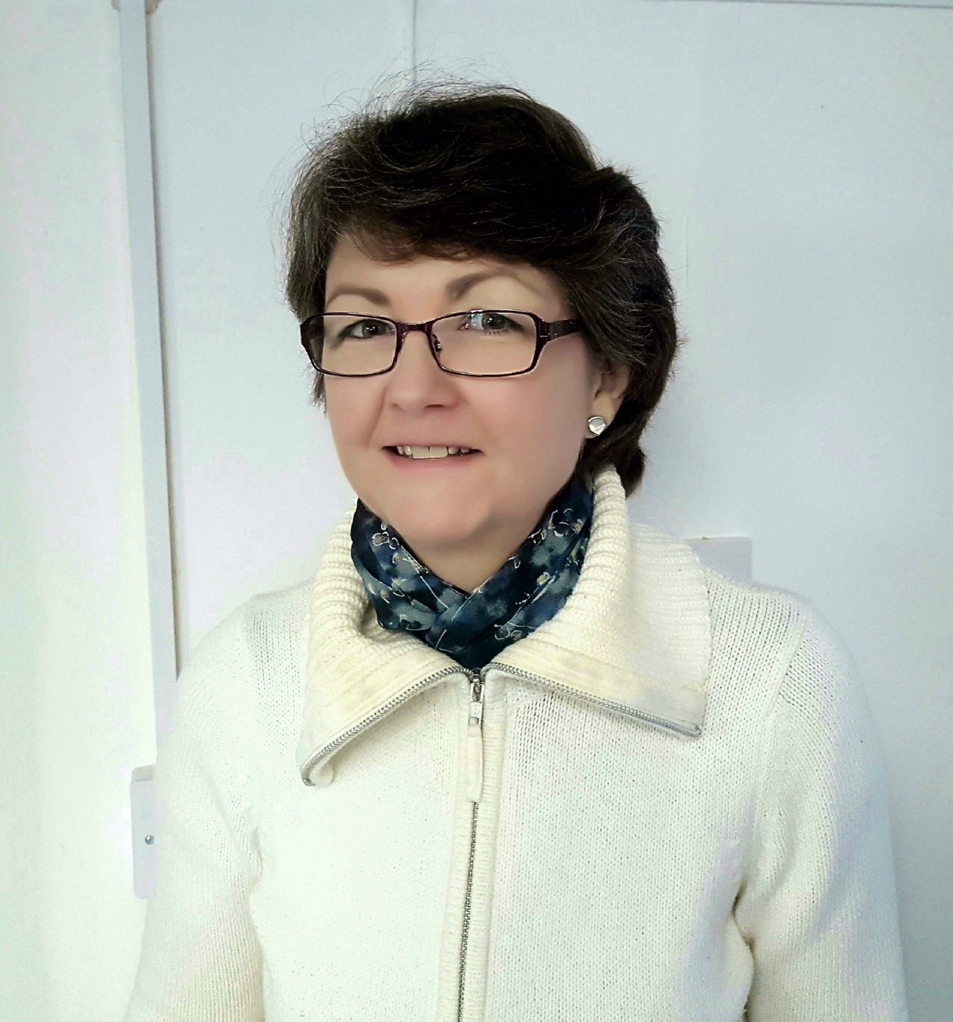

Generation Hope – Our Youth Branch
In 2017, Generation Hope started 'workshop days' for young people. The first was a drug awareness day, where participants learnt about what drugs do, their effects and dangers, and also practiced skills that they might want to use in a situation where drugs are being used or offered. The second workshop was about developing confidence. Both days were led by Hope UK staff and Generation Hope young people.
Generation Hope members also worked at Soul Survivor and Big Church Day Out - doing detached drug education and telling people about the work of Hope UK.
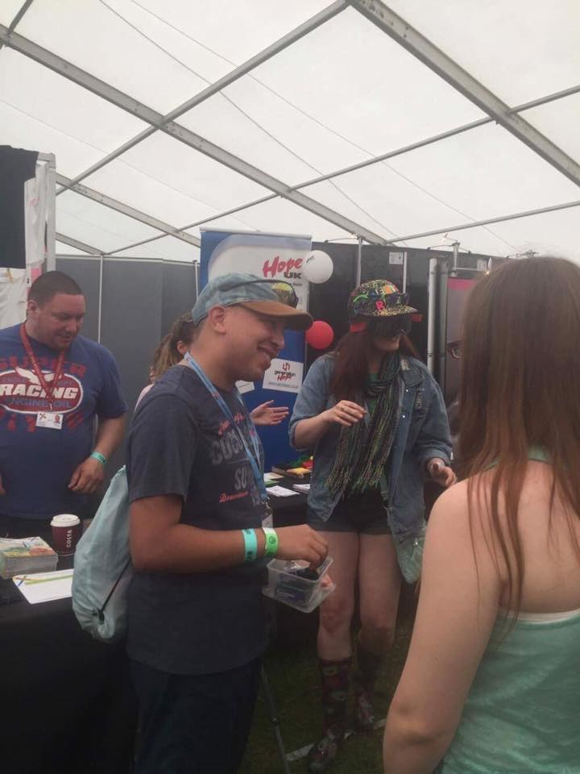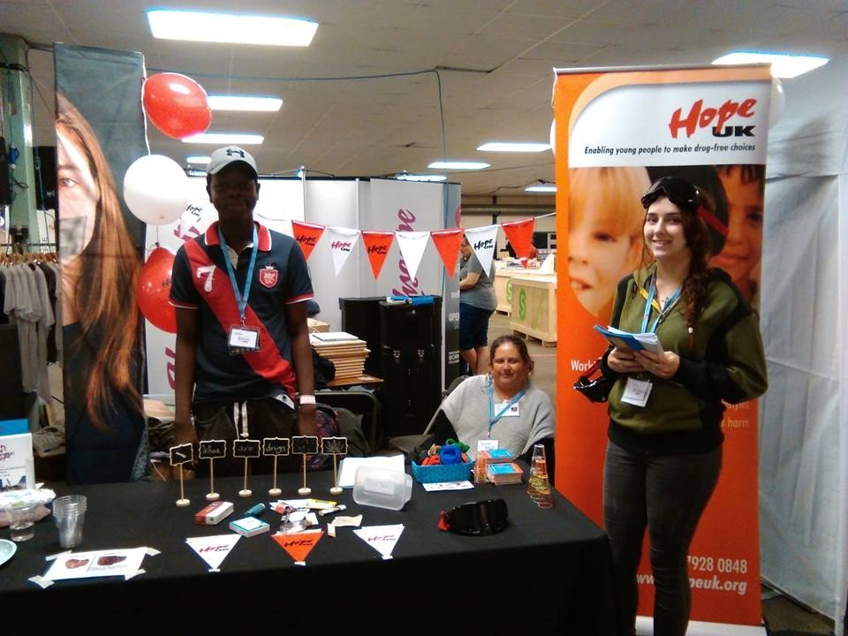
Young members of Generation Hope helped out at all kinds of sessions and events - including meeting Jeremy Corbyn and carol singing at Trafalgar Square! They also led training sessions for Hope UK volunteers at our Annual Conference.
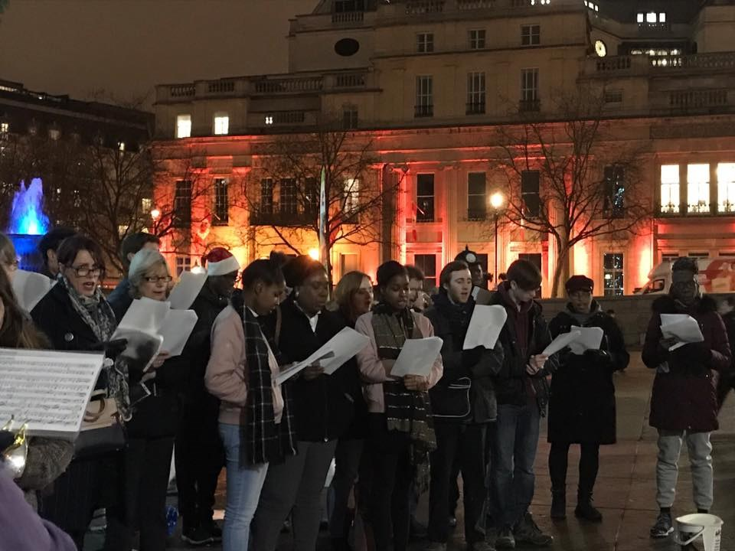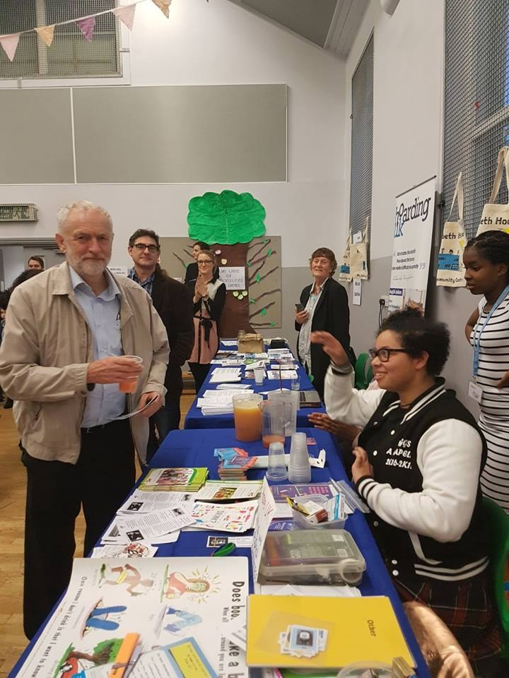
We also hosted residential weekends - one for 11-14s, one for those 15 and over, and one to train young leaders - who will be helping leading activities in 2018 and beyond.
The number of young people attending Generation Hope events in 2017 increased significantly, with the number of young people in contact with us nearly doubling.

What young people told us:
“I enjoyed every part of it”
“THE BEST WEEKEND EVER!!!”
“Great, Funny, Fantastic”
“They were enjoyable and getting to be on teams with some people you haven't really spoken to. Those were opportunities for me to get to know people better”
“It was fun and inclusive with some competition for good measure”
“The leaders were great. When you needed them they were there.”
“The main issue of today’s youth, amongst girls particularly, is that they have absolutely no self-confidence. I hear too much of “I’m so ugly”, “I’m so fat, no boy/girl is ever going to look at me twice”, “I’m super nervous about everything”, “I’m gonna do terrible at this”. And that they do not have the confidence to stand up for themselves and they let other people push them around. The good thing about Generation Hope is that we are taught how to be confident, and how to say ‘no’. These are two life skills that we are not taught in school, but should be. It is really important that we learn these things, so it is really good we have organisations like Generation Hope who will teach us these things.”
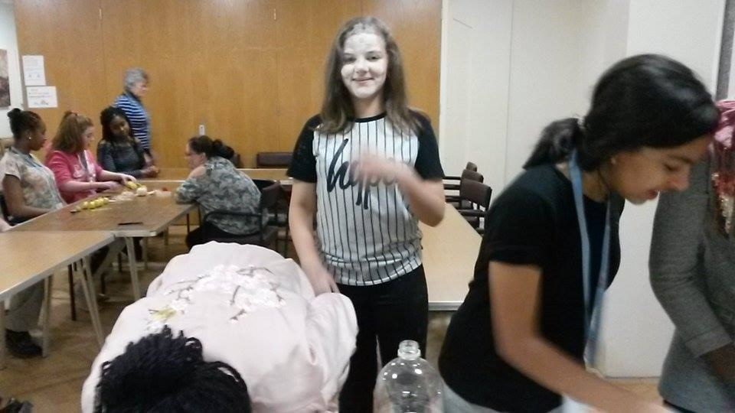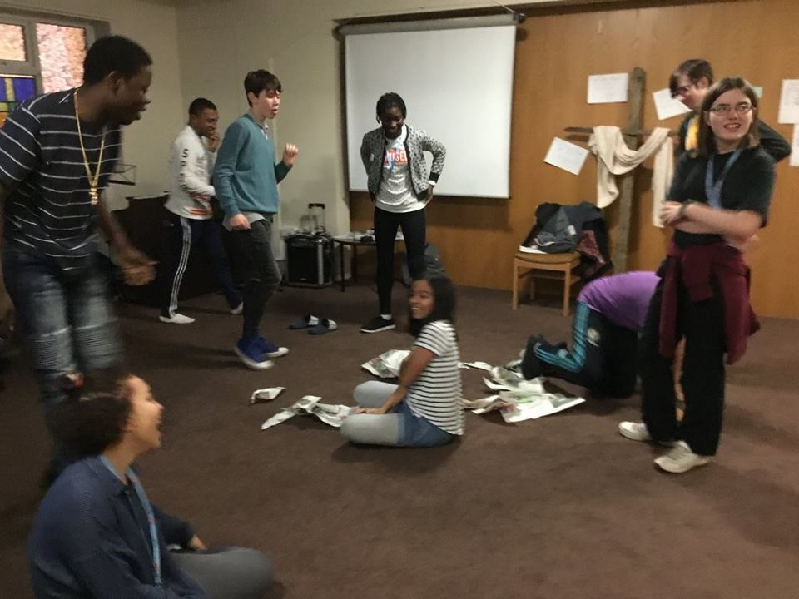

Our Drug Prevention Work
In 2017, our staff and volunteers continued to deliver high quality, bespoke drug awareness and life skill sessions to a wide variety of groups. We worked in schools, colleges, universities, youth clubs and community centres. Our workers trained volunteers and professionals who work with children and young people. Other Hope UK representatives led informal drug awareness education (‘detached work’) in libraries, at freshers’ fairs, in shopping centres and at market stalls.
We took 1,500 sessions around the UK, mostly led by our small team of volunteers. This was less than in 2016, as we deliberately slowed down developing this work, to give us time to restructure and manage the move. We reached about 50,000 young people.
The tables below summarise evaluation data collected during 2017:
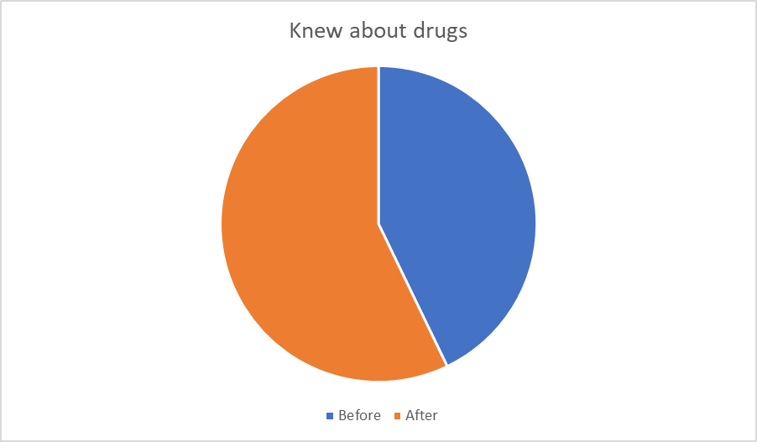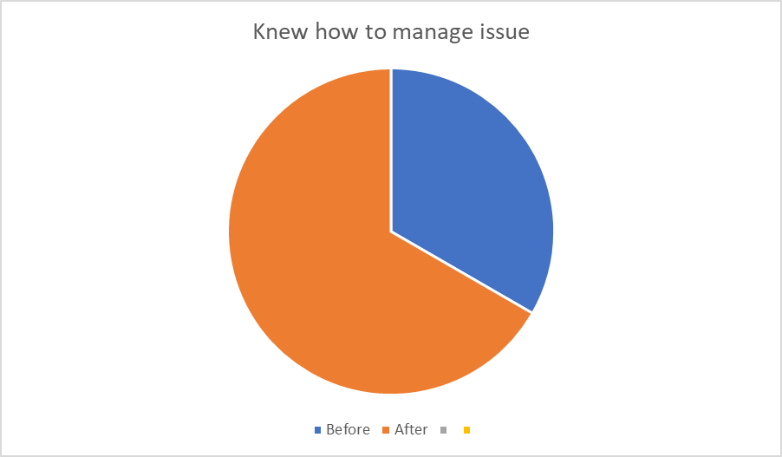

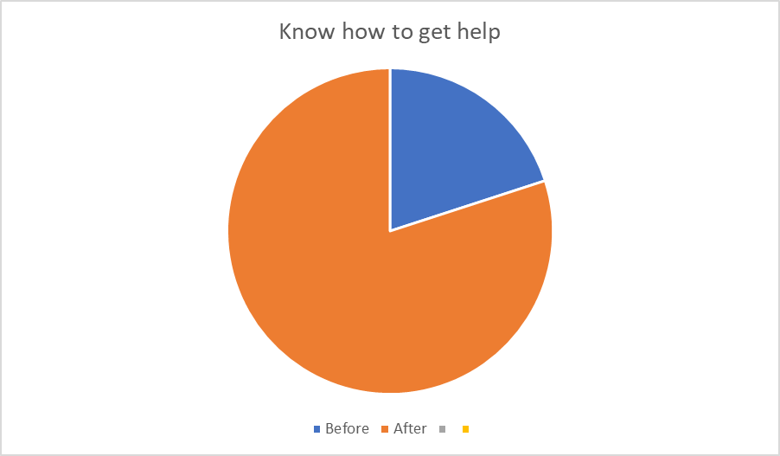

What people said about us:
“I wish they’d come in all the time, I’ve learnt so much about drugs today. I don’t understand why all education isn’t like this” – Overheard at an FE college.
“Just want to say that the lady in the library demonstrating the caffeine content of drinks on Saturday morning was great. She has really made me aware of my addiction to caffeine. I'm currently detoxing and it’s not great but I am very grateful to her for spending the time to explain to me. Great work that’s making a difference thank you lovely lady”. Library visitor.
“Useful – Clarification of law in practical situations because there were some surprises about what is and is not legal.” University Students.
“A very informative session that allowed the children to consider the risks of drugs. All activities in line with science curriculum and well resourced. We look forward to hopefully further sessions in the future.” Primary School Teacher.
“Very interactive presentation covering all areas of the substance scene misuse. Very active session with all having opportunity to participate.” Street Pastor.
“What you’re doing is really good, I’ve been on a detox for months but messed it up last night. I wish I’d known more when I was younger, my life wouldn’t have been like this. Not a homeless addict with nothing to do”. Street Drinker at a detached stand.

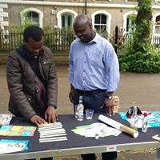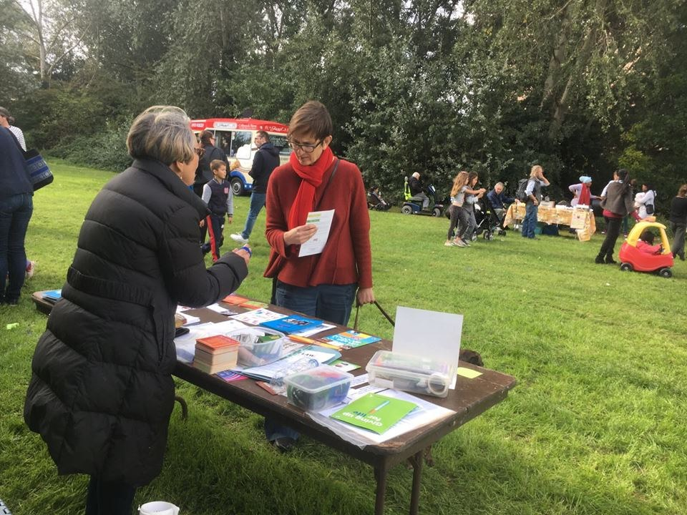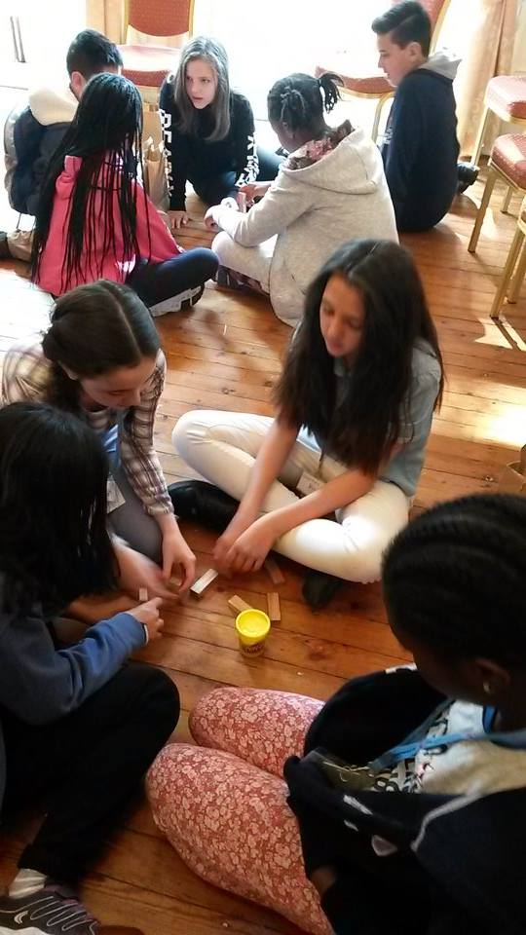

Statement of Financial Position
INCOME | 2017 (£) | 2016 (£)
Voluntary income (eg, gifts and grants from trusts/companies) | 85,445 | 148,397
Investment income | 14,917 | 13,741
Incoming resources from charitable activities  *(eg service provision) | 1,645 | 5,730
Other income | 841,226 | 78,199
Total incoming resources | 943,233 | 246,067
EXPENDITURE | 2017 (£) | 2016 (£)
General education activities | 334,277 | 369,441
Fundraising and publicity | 13,125 | 38,280
Investment management costs | 4,609 | 3,960
Governance costs | 4,042 | 3,685
Total resources expended | 356,053 | 415,366

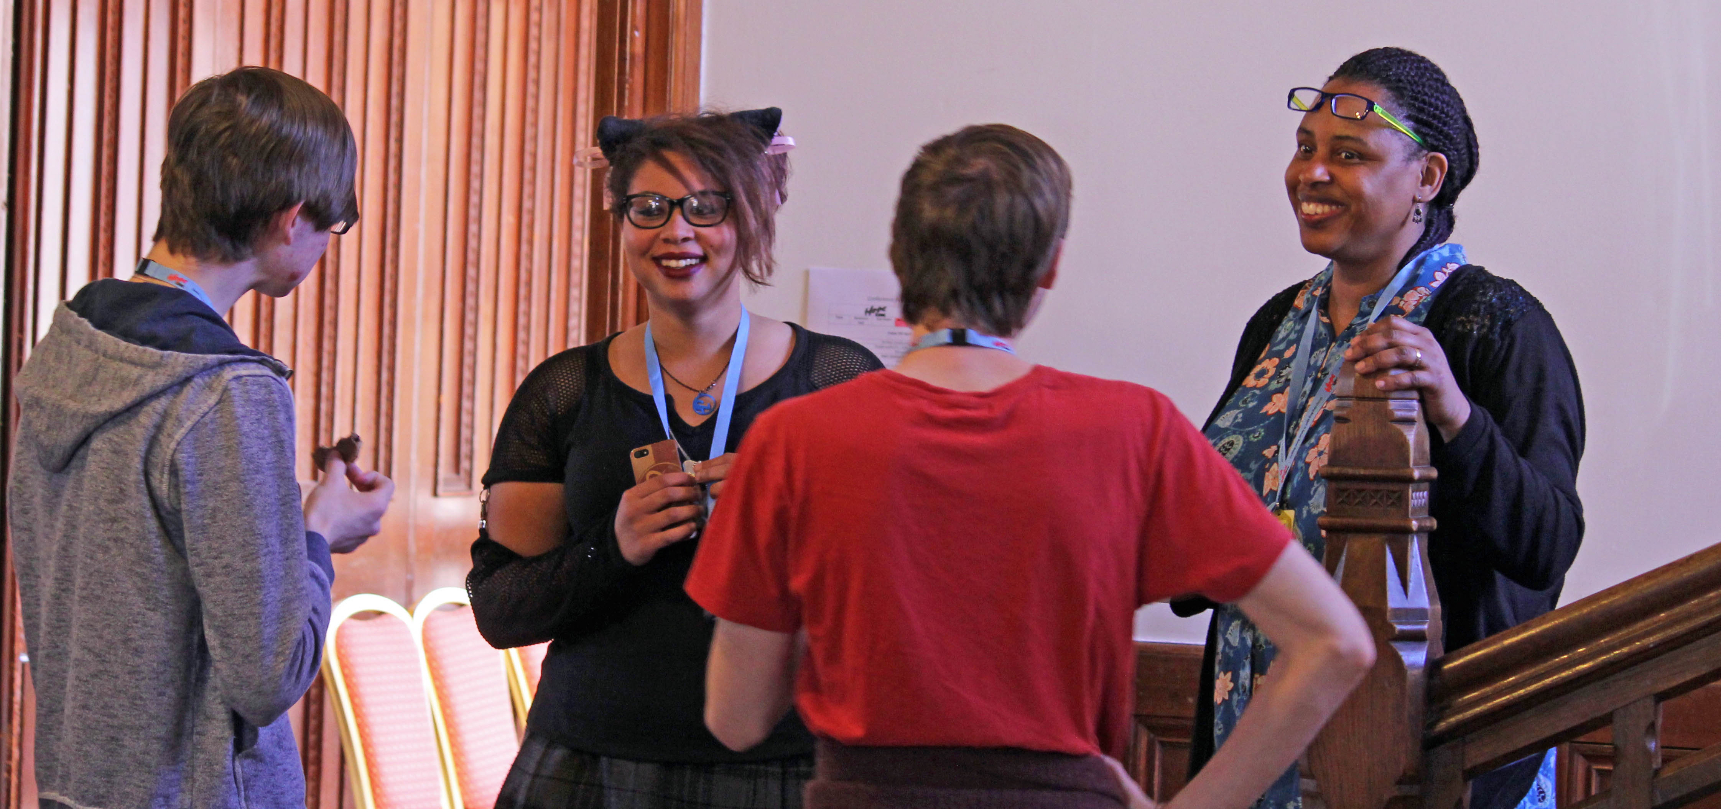
Balance Sheet as at 31/12/2017

FIXED ASSETS | 2017 (£) | 2016 (£)
Tangible assets | 194 | 309,945
Investments | 1,241,160 | 381,001
 | 1,241,354 | 690,946
CURRENT ASSETS
Debtors | 3,752 | 9,801
Bank & Cash in hand | 220,367 | 135,792
 | 224,119 | 145,593
Creditors falling due within 1 yr | (16,127) | (24,203)
Total assets less current liabilities | 1,449,346 | 812,336
INCOME FUNDS
Restricted funds | 132,630 | 169,861
Designated funds–tangible fixed assets | 0 | 309,945
Unrestricted funds | 1,316,716 | 332,530
 | 1,449,346 | 812,336

Hope UK
50 Gold Street
Kettering, NN16 8JB
Tel 020 7928 0848
Website www.hopeuk.org
Registered with the Charity Commission No. 1044475
Ltd Company registered in England and Wales No 3022470
Registered with the Office of the Scottish Charity Regulator No. SC040550

